Sophos Firewall: Firmware Update Guide

Luis Lazo
Purpose: Update Firewall firmware via Sophos Central for customer appliances (NO affect endpoints).

Step-by-Step Instructions

1. Login to Sophos Central
• Go to central.sophos.com → My Products > Partner Portal.

2. Navigate to Customer
• My Business > My Customers > Customers.
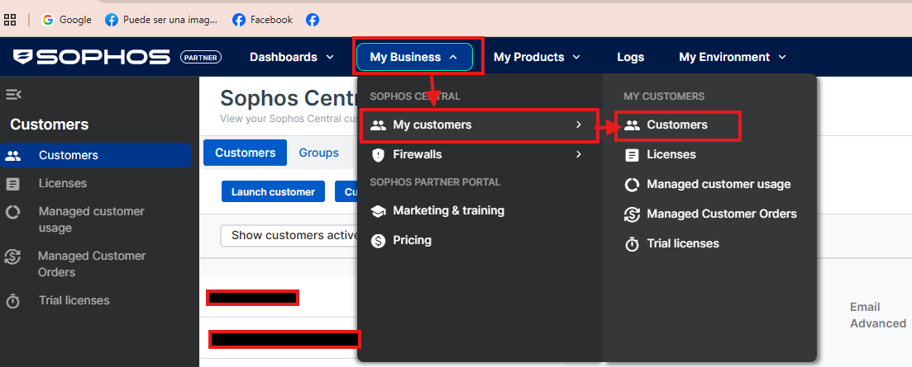
3. Launch Customer Portal
• Click Launch Customer (opens new window/tab).
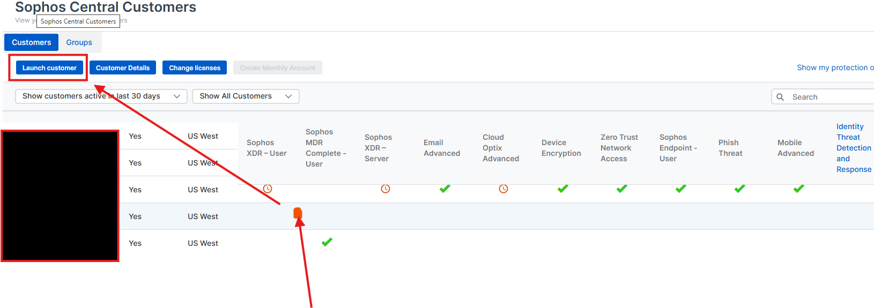

4. Access Firewall
• My Products > Firewall Management > Firewall.
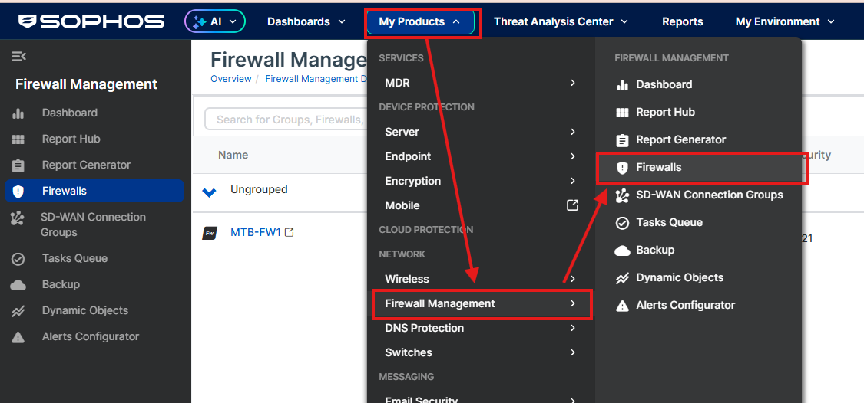
• Click the Firewall
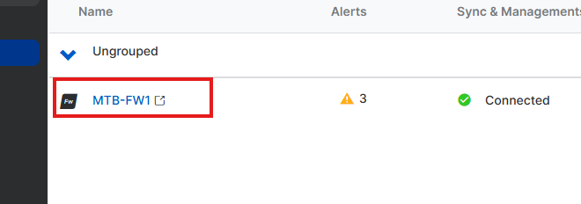

5. Update Firmware
• Left panel: BACKUP & FIRMWARE > Firmware.
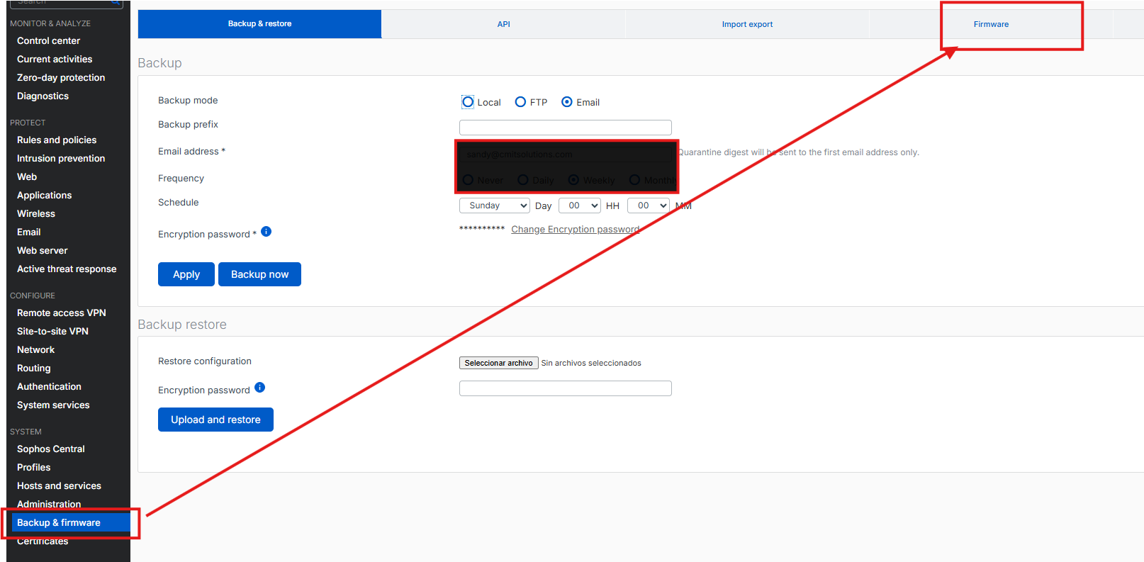
• See current version → Check for updates → Download & Install (select SFOS version).
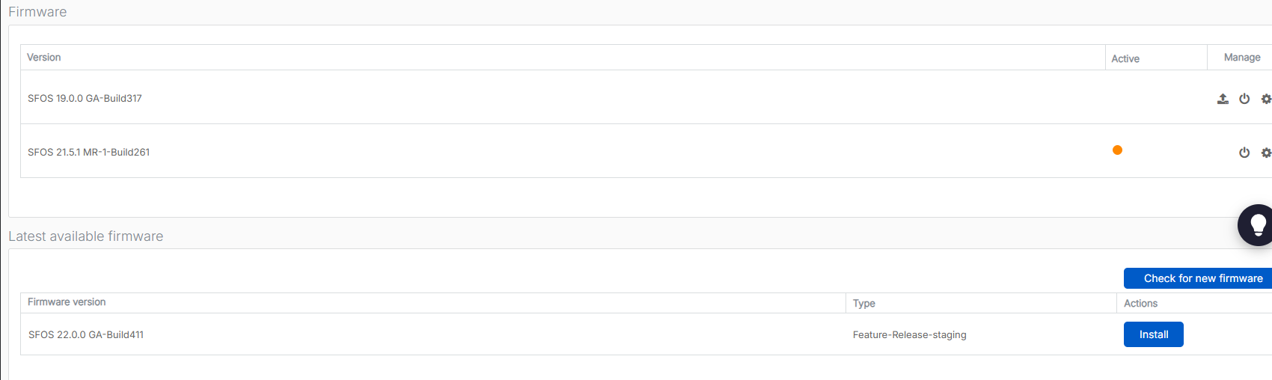

Author: Luis Lazo

